Decomposers Worksheets: Contents

What Happens to Dead Plants and Animals? 2
Rotten Work Investigation 3
Initial Explanation and Prediction 3
Measurements During the Investigation 4
Explaining Your Results 5
Under The Lens 6
Fungus Growth: Digestion and Biosynthesis 8
Before Viewing the PowerPoint 8
Digestion and Biosynthesis: After Building Molecular models and Viewing the PowerPoint 9
Investigating the Missing Mass 11
Initial Explanation and Prediction 11
The Air Around Decomposition: Measurements During the Investigation 12
Explaining Your Results 13
Changing Dead Plants And Animals To Gases 14
Before Viewing the PowerPoint 14
Using molecular models 15
Explaining how Decomposers Function: After Building Molecular models, Reading about Decomposition, and Viewing the PowerPoint 16
Evidence of Decomposers Living In Soil 17
Other Examples of Digestion, Biosynthesis, and Cellular Respiration in Decomposers 18
Questions about Combustion 18
Questions about Other Chemical Changes 18
Predicting and Explaining an Example of Chemical Change in decomposition 19
Predicting and Explaining an Example of Chemical Change in Decomposition 20

Name:_____________________ Period:____ Date:_________

What Happens to Dead Plants and Animals?

1. When leaves fall from trees they land on the forest floor. With enough time these leaves “decompose”. Like leaves, animals may die in the forest and decompose. What happens to the matter that makes up these dead plants and animals?

2. Do the dead plants and animals still have energy? If so, what form of energy do they have? If not, where did the energy go?


3. Here are three explanations about what happens when bread begins to grow mold and rot. Circle the one you think is best.
Alex: Mold grows on the bread because the bread is rotting. Mold just helps the bread rot faster.
Carmen: When mold eats the bread it turns the bread into gases that go into the air.
Blake: Mold eats the bread and it turns the bread into energy during cellular respiration.

Why do you think your choice is best?

5. Write your own explanation for how something “rots”. What happens to the matter that makes up the rotting material? What happens to energy during the rotting process?

Name:_____________________ Period:____ Date:_________

Rotten Work Investigation

Initial Explanation and Prediction
When mold grows there are hidden chemical changes—transformations in matter and energy that take place when molecules are split apart and their atoms combine into new molecules. In chemical changes reactants (materials that are in the system before the change) always change into products (materials that the reactants change into).
In this investigation you will leave grow mold on
Jell-O for a few days, so you will have to figure out what the reactants and products are when the mold grows. Think about what materials are losing mass (that would be the reactants) and what materials are gaining mass (that would be the products). Try explaining and predicting how those materials change.
Your explanation: How are reactants changing into products when mold grows?

Your prediction: What changes in reactants or products could we measure or observe?

Using the Process Tool to show your explanation and prediction: Show your ideas about how matter and energy change when mold grows on the process tool diagram below.
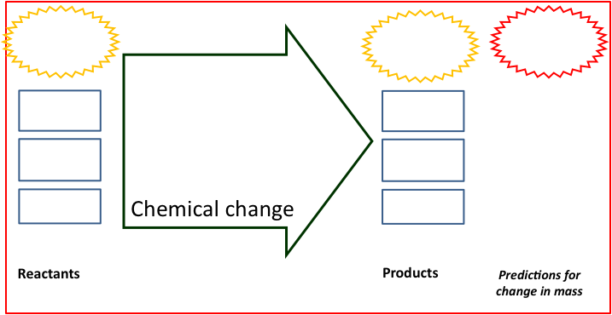
Name:_____________________ Period:____ Date:_________

Measurements During the Investigation

My Data and Observations:
 | Decomposer Sample | Start Mass | After 1 Day | End Mass | Mass Change
1
2
3
4
5
6
7
8

Observations
Describe what you see happening on your Jell-O dishes. Is anything growing?

Results
Briefly summarize the main patterns that you saw:
What gained mass during your investigation?

What lost mass during your investigation?

Explaining Your Results
Claims—your revised explanation: How are reactants changing into products when mold grows?

Using the Process Tool: Show your new ideas about how reactants changed into products on the process tool diagram below.
Evidence—the measurements that support your explanation: What are the key observations and measurements that support your explanation?

Reasoning—connecting claims to evidence and scientific principles
Connecting explanations and evidence: How does the evidence support your explanation?

Connecting evidence and principles. Does your explanation follow the principles that apply to chemical changes?
Yes No Not sure Conservation of matter: Materials (solids, liquids, or gases change into other materials, but matter is not created or destroyed.
Yes No Not sure Conservation of mass: The masses of reactants and products are equal.
Yes No Not sure Conservation of energy: Energy is not created or destroyed.
Yes No Not sure Conservation of atoms: Atoms are not created or destroyed.

Name:_____________________ Period:____ Date:_________

Under The Lens
Directions: You will make observations of decomposers using hand lenses and microscopes. For each sample, you will record the different organisms and materials you see. As you make your observations, estimate the size of the organism (macroscopic organisms you can see with your eyes or using a hand lens; microscopic organisms can only be seen using the microscope). You will need to follow instructions for preparing microscope slides as directed by your teacher.

Materials
- Hand lens activity: Samples of soil, leaf litter, compost, hand lens, and forceps
- Microscope activity: Microscope slide, dropper, distilled water, extra cup

Observation #1: Using your hand lens

 | Write down or draw different organisms you see in the sample. | Write down or draw different materials you see in the sample.
Sample #1: _____________

Color:

Moisture (wet or dry):

Other descriptions:

Sample #2: _____________

Color:

Moisture (wet or dry):

Other descriptions:

Sample #3: _____________

Color:

Moisture (wet or dry):

Other descriptions:

Observation #2: Microscopes

Procedures
- Send one partner to make your microscope slide. To do this you will need to get a slide and with tweezers, pick out a small sample of organic material to put on the slide. With a dropper, put a drop or two of the liquid surrounding the soil or compost on the slide too. Leave the dropper with the decomposition sample.
- Place the slide with the sample on the stage of the microscope. Make sure the 4x objective lens is in place. Focus on the sample. You may need to zoom in even further as you study your sample.
- Search for signs of life in the sample. When you find something, draw it in your observation table below, noting which type of sample is being examined. If you see more than one creature of the same type, note the approximate number you find next to its drawing.
- Once finished, wipe off the sample with a clean paper towel, rinse with distilled water and then you are ready to prepare another slide for observation using a different sample.

 | Write down or draw different organisms you see in the soil. | Write down or draw different materials you see in the soil.
Sample #1:

Sample #2:

Sample #3:

Some people say that soil is “just dirt”. Now that you made observations of different types of soil, what else could you say about soil?

Name: _____________________ Period: ______ Date: _________

Fungus Growth: Digestion and Biosynthesis

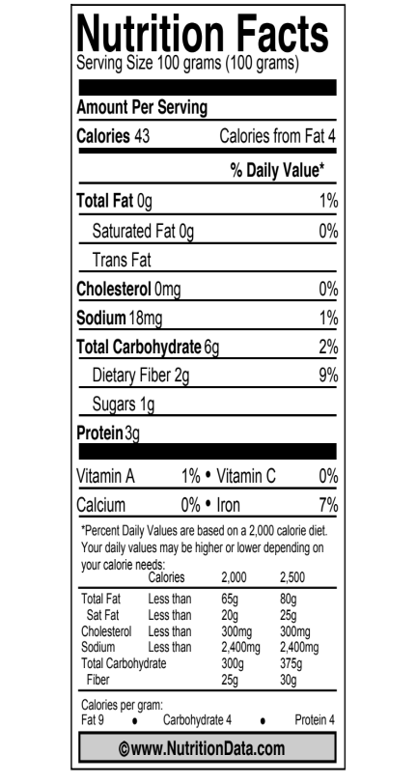
Before Viewing the PowerPoint
A mushroom is the fruiting body of a fungus (sort of like the apple on a tree). It spreads spores from the fungus to other places where it might grow. The main body of the mushroom is called the mycelium; it is an underground network of thin fibers called hyphae.
The Nutrition Facts label shows some of the materials that are in mushrooms. Look at the label and list some of the important materials in mushrooms:
Materials in mushrooms:
1.

2.

3.

4.

The fungus depends on dead plants and animals as a food source. List some of the materials that you would expect to find in dead plants and animals. (Hint: Can you find other nutrition labels that show the materials in dead plants and animals?)
Materials in dead plants and animals:
1.

2.

3.

4.

How do you think the mushroom fungus can make the materials in the mushroom out of the materials in dead plants and animals?

Name: _____________________ Period: ______ Date: _________

Digestion and Biosynthesis: After Building Molecular models and Viewing the PowerPoint

Describe your revised ideas about how a fungus can transform materials in dead plants and animals into materials in a mushroom.

Location #1: Outside the hyphae
Explain what is happening to the large organic molecules in food outside the hyphae of the fungus.

Use the process tool to show what happens to one material in grass.

Location #2. Movement of materials to the mushroom
In order for the mushroom to grow, it must get materials from somewhere. Explain how the small organic molecules get to the mushroom—the fruiting body of the fungus.

Location #3. Transformation of materials inside the mushroom cells
The mushroom cells are made of large organic molecules—especially protein and carbohydrates—as well as water and other materials. Explain how the mushroom cells make the large organic molecules as they grow.

Use the process tool to show what happens to one material in the mushroom is made.

4. Checking your explanation
Does your explanation follow the principles that apply to chemical changes?
Yes No Not sure Conservation of matter: Materials (solids, liquids, or gases) change into other materials, but matter is not created or destroyed.
Yes No Not sure Conservation of mass: The masses of reactants and products are equal.
Yes No Not sure Conservation of energy: Energy is not created or destroyed.
Yes No Not sure Conservation of atoms: Atoms are not created or destroyed.

Name:_____________________ Period:____ Date:_________

Investigating the Missing Mass

Initial Explanation and Prediction
In chemical changes reactants (materials that are in the system before the change) always change into products (materials that the reactants change into). When the mass of the reactants in a chemical change doesn’t equal the mass of the products, there must be some material that we aren’t measuring properly.
In this investigation you will leave mealworms without food for a day or so, so you will have to figure out what the reactants and products are when mealworms are moving around, but not eating or growing. What materials do you think that the mealworms are using as energy sources for their movement? How are those materials changing?
Your explanation: How are reactants changing into products when mealworms move?

Your prediction: What changes in reactants or products could we measure or observe?

Using the Process Tool to show your explanation and prediction: Show your ideas about how matter and energy change when mealworms grow on the process tool diagram below.

Name:_____________________ Period:____ Date:_________

The Air Around Decomposition: Measurements During the Investigation

In these investigations you will test whether CO₂ and water vapor are given off from decomposition. You will need to gather a few additional materials to set-up your investigations, and carefully follow the procedures below.
Investigation #1: Test for Carbon Dioxide with BTB
Data:
 | Start Mass/ Color | End Mass/ Color | Mass Change  OR Color Change
MASS of Jell-O-Decomposer Sample
MASS of BTB Solution
COLOR of BTB Solution

Investigation #2: Test Carbon Dioxide with Soda Lime
Data:
 | Start Mass | End Mass/ | Mass Change
MASS of Jell-O-Decomposer Sample
MASS of Soda Lime

Results
Briefly summarize the main patterns that you saw:
What gained mass during your investigation?

What lost mass during your investigation?

Explaining Your Results
Claims—your revised explanation: How are reactants changing into products when mold grows on Jell-O?

Using the Process Tool: Show your new ideas about how reactants changed into products on the process tool diagram below.
Evidence—the measurements that support your explanation: What are the key observations and measurements that support your explanation?

Reasoning—connecting claims to evidence and scientific principles
Connecting explanations and evidence: How does the evidence support your explanation?

Connecting evidence and principles. Does your explanation follow the principles that apply to chemical changes?
Yes No Not sure Conservation of matter: Materials (solids, liquids, or gases change into other materials, but matter is not created or destroyed.
Yes No Not sure Conservation of mass: The masses of reactants and products are equal.
Yes No Not sure Conservation of energy: Energy is not created or destroyed.
Yes No Not sure Conservation of atoms: Atoms are not created or destroyed.

Name:_____________________ Period:____ Date:_________

Changing Dead Plants And Animals To Gases

Before Viewing the PowerPoint
When a mushroom grows, it gets energy from organic materials. Explain your ideas about how a fungus can use chemical energy from organic materials to grow.
1. Transformation of materials when mushroom cells function
Materials the mushroom uses: List your ideas about the main organic and inorganic materials that a mushroom needs for energy. (Hint: Don’t forget gases.)  1.  2.  3.  4. | Transformation of materials in the mushroom cells: Explain how you think those materials might be changed when the fungus uses them for energy.
Use the process tool to show your ideas about a chemical change that supplies mushroom cells with energy.
2. Movement of materials to the mushroom cells
In order for the mushroom cell to function, it must get materials from somewhere. Explain your ideas about how the materials get to the mushroom cell.

Name: _____________________ Period: ______ Date: _________

Using molecular models
You will use molecular models to show how decomposers change organic matter (especially dead organic matter) into other forms of matter. Record what happens to the atoms and bonds during this process.
Use the molecular models to figure out how glucose combines with oxygen in cellular respiration:
- Follow the instructions on the handout to make models of an ethanol molecule (C₆H₁₂O₆) and about 7 oxygen molecules (O₂, with a double bond)
- The cow’s muscle cells can break the bonds in the glucose and oxygen molecules, so you can take them back apart.
- Now they can recombine into carbon dioxide (CO₂) and water vapor (H₂O), releasing chemical energy for the work of the muscles. Make as many of these molecules as you can.
- Figure out numbers of molecules:
  - How many O₂ molecules do you need to combine with one glucose molecule?
  - How many CO₂ and H₂O molecules are produced from one molecule?
- Write the chemical equation for the cellular respiration reaction:
C₆H₁₂O₆ + ? O₂ → ? CO₂ + ? H₂O

Use the table below to account for all the atoms and bonds in your models.
 | Matter |  |  | Energy
 | How many  carbon atoms | How many  oxygen atoms | How many  hydrogen atoms | Chemical energy: Yes or No?  (C-C; C-H Bonds)
Began with…
Glucose
Oxygen
End with…
Carbon Dioxide
Water

Name: _____________________ Period: ______ Date: _________

Explaining how Decomposers Function: After Building Molecular models, Reading about Decomposition, and Viewing the PowerPoint
Describe your revised ideas about how a fungus can use chemical energy from organic materials to grow and function.
1. Transformation of materials when mushroom cells function
Materials the mushroom uses: List your ideas about the main organic and inorganic materials that a mushroom needs for energy.  1.  2.  3.  4. | Transformation of materials in the mushroom cells: Explain how you think those materials might be changed when the fungus uses them for energy.
Use the process tool to show your ideas about a chemical change that supplies mushroom cells with energy.

3. Checking your explanation
Does your explanation follow the principles that apply to chemical changes?
Yes No Not sure Conservation of matter: Materials (solids, liquids, or gases) change into other materials, but matter is not created or destroyed.
Yes No Not sure Conservation of mass: The masses of reactants and products are equal.
Yes No Not sure Conservation of energy: Energy is not created or destroyed.
Yes No Not sure Conservation of atoms: Atoms are not created or destroyed.

Name:_____________________ Period:____ Date:_________

Evidence of Decomposers Living In Soil
Decomposers living in soil can take many forms. Some we can see with our eyes while many are invisible to us without microscopes. Today we are going to “feed” soil microbes two different types of food: sugar and starch, and watch how the soil microbes respond to the addition of food.

Predictions
 |  | Explain your prediction
If we measure CO₂ around a sample of soil with nothing added to it, what do you think will happen to the CO₂ levels? | ◻ increase  ◻ be the same  ◻ decrease
If we feed soil microbes sugar, what do you think will happen to CO₂ levels in the air around the microbes? | ◻ increase  ◻ be the same  ◻ decrease
If we feed soil microbes starch, what do you think will happen to CO₂ levels in the air around the microbes? | ◻ increase  ◻ be the same  ◻ decrease

Observations
Soil Type | Additive | Starting CO₂ | 5 minutes | 10 minutes | ___ minutes

Which soil sample do you think has the most decomposers? Explain why you think this using the evidence above.

Other Examples of Digestion, Biosynthesis, and Cellular Respiration in Decomposers

Questions about Combustion

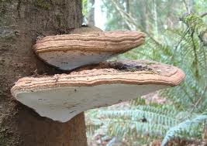
1. Choose two examples of other changes involving decomposition
- Leaves fall from trees and decay on the forest floor
- Cheese that is left in the refrigerator too long gets moldy
- Shelf fungus grows on a dead tree (see picture)
- A farmer grows clover as a cover crop, then plows it into the soil, releasing nutrients for her vegetable crops (hint: clover has lots of protein, and some decomposers can use amino acids as an energy source for cellular respiration)
- A farmer leaves wet hay in his barn, and it heats up so much that it catches on fire (for a 5-minute video, see http://www.youtube.com/watch?v=zRNCrHqD0zE)
2. Use the Process Tool and questions on the next two pages to predict what will happen in your examples.
3. (Optional): Use molecular models to show what happens inside the cells of the decomposer.

Questions about Other Chemical Changes
Connect to combustion: Of the three kinds of chemical changes that you studied in decomposers:
- Digestion
- Biosynthesis
- Cellular respiration
Which change is most like combustion, the chemical change that you studied in Systems and Scale? Explain your reasoning.

Stump the class: The Law of Conservation of Mass says that mass is conserved in EVERY chemical and physical change, including all changes that occur in animals. Can you think of an example of decomposition where mass is not conserved?
1. Try to think of an example where mass seems to disappear—the products at the end are lighter than the reactants at the beginning. Can anyone in the class suggest a possible explanation?
2. Try to think of an example where mass seems to be created—the products at the end are heavier than the reactants at the beginning. Can anyone in the class suggest a possible explanation?
Name: _____________________ Period: ____ Date: ________

Predicting and Explaining an Example of Chemical Change in decomposition
1. Write your own explanation for what chemical changes are involved in this process.
2. Predict what happens to the masses of materials involved in this process.

3. Explain what happens to the chemical energy stored in the C-C and C-H bonds of organic materials.

4. Use the process tool to identify the reactants, products, and energy changes.

5. Does your explanation follow the principles that apply to chemical changes?
Yes No Not sure Conservation of matter: Materials (solids, liquids, or gases) change into other materials, but matter is not created or destroyed.
Yes No Not sure Conservation of mass: The masses of reactants and products are equal.
Yes No Not sure Conservation of energy: Energy is not created or destroyed.
Yes No Not sure Conservation of atoms: Atoms are not created or destroyed.

Name: _____________________ Period: ____ Date: ________

Predicting and Explaining an Example of Chemical Change in Decomposition
1. Write your own explanation for what chemical changes are involved in this process.
2. Predict what happens to the masses of materials involved in this process.

3. Explain what happens to the chemical energy stored in the C-C and C-H bonds of organic materials.

4. Use the process tool to identify the reactants, products, and energy changes.

5. Does your explanation follow the principles that apply to chemical changes?
Yes No Not sure Conservation of matter: Materials (solids, liquids, or gases) change into other materials, but matter is not created or destroyed.
Yes No Not sure Conservation of mass: The masses of reactants and products are equal.
Yes No Not sure Conservation of energy: Energy is not created or destroyed.
Yes No Not sure Conservation of atoms: Atoms are not created or destroyed.

